A little more on DNA

As stated in the post, autosomal DNA (atDNA) comes to us from many ancestors, both male and female. Parents contribute approximately 50% each to us, so our grandparents each contribute about 25%, great grandparents approximately 12.5% and so on as the generations go back. Once the percentage of contribution from our more distant (around 6 generations back) ancestors gets down to less than 2%, it can drop out entirely due to how DNA combines, leaving us with no DNA from specific ancestors. Here is a chart showing many of the ancestors who contributed to the DNA of the children (outlined in purple) in this family.

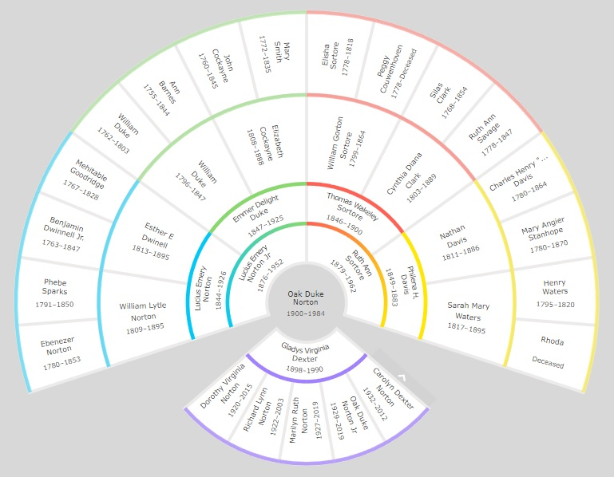

Y-DNA is quite different. In each generation, it can be inherited by males only from one specific ancestral line, which also passes on the surname. In the Y-DNA chart, only those in blue receive and pass on Y-DNA, which ultimately comes down to the two male children at the bottom of the chart.

Because Y-DNA can pass through many generations with very little mutation, it can be used to identify distant cousins who belong to the same haplogroup (individuals who share genetic mutations derived from a common ancestor). It can further identify the approximate distance between genetic cousins within a haplogroup based on the minute differences in their Y-DNA markers which are called Short Tandem Repeats. I won’t get into more detail than that and will sum this up by saying the genetic distance within the same haplogroup is determined by the number of small differences in STR markers within Y-DNA test results.

For the Starbuck DNA testing project, other Starbuck males tested, but due to non-parental events, or possibly the use of alias surnames by ancestors, some testers were not genetically related to Edward Starbuck, at least not within the last few thousand years. Other Starbucks were related within less than twelve generations but did not have family trees that went back far enough for ancestral comparisons. Additional testing by Starbuck males in the UK, or those with ancestors who migrated from England more recently, can provide additional evidence, or possibly refute what was found.

One thing to be aware of is that a Y-DNA testing company can test as few as 12 or as many as 700 genetic markers, depending on what the customer is willing to pay. The four Starbuck men in the comparison all tested at the 111 level or higher, meaning a good comparison could be done for 111 different genetic sequences.

R-M198 is a subgroup of the major haplogroup R1a1, which is a rarity in England according to Dr. Turi King and other researchers at Leicester University. They placed the haplogroup’s percentage as approximately 6% of English males. The haplogroup is more common in continental Europe and Scandinavia, an indication, Dr. King believes, the surname has a Norse origin.

ISOGG Wiki, “Short Tandem Repeat,” rev. 14:10, 31 January 2017. States: STRs (short tandem repeat) in DNA occurs when a pattern of two or more nucleotides are repeated and the repeated sequences are directly adjacent to each other. By identifying repeats of a specific sequence at specific locations in the genome, it is possible to create a genetic profile of an individual. Y-chromosome STRs (Y-STRs on the Y chromosome) are used in genealogical DNA testing in surname DNA projects.
Alias surnames were not used for nefarious purposes but rather for further identification. An individual might choose a secondary surname to help differentiate himself from others nearby who had the same surname, or to show inheritance, ties to another family line, and so on. See this article at FamilySearch for more information: https://www.familysearch.org/en/wiki/Use_of_Aliases_-_an_Overview
FamilyTreeDNA is currently the only testing company which offers Y-DNA tests.
Lall, Gurdeep Matharu, Maarten H. Larmuseau, Jon H. Wetton, Chiara Batini, Pille Hallast, Tunde I. Huszar, Daniel Zadik, et al. “Subdividing Y-Chromosome Haplogroup r1a1 Reveals Norse Viking Dispersal Lineages in Britain.” European Journal of Human Genetics 29, no. 3 (2020): 512–23. https://doi.org/10.1038/s41431-020-00747-z.

