Richard KENDALL alias MILLS, carpenter (1628-1684) – what we know of him and his descendants

1628, (6 July) | Richard son of Rafe Milles (brother of Woburn Francis) was baptized at Sherington.
Ca. 1640 | Richard’s elder brothers, Francis and Thomas, left for Massachusetts.
1652 (9 Dec) | Richard of Newport Pagnell married Elizabeth Wite of Wellingborough, Northamptonshire in Tottenham, Middlesex. Elizabeth may have been the daughter of John, bap 1635 in Wellingborough.
1653 (10 Mar) | Richard Mills, son of Richard & Elizabeth was baptized in Enfield, Middlesex.
1655 (10 Sep) | John Mills, son of Richard & Elizabeth was baptized in Enfield, Middlesex
1657 (10 Aug) | [blank] the [blank] of Richard Mills was baptized Enfield, born 26 July. The name and gender was left out of the register, but this may be Elizabeth who was named in her grandfather Ralph’s will.
1657 (1 Oct) | Rafe Mills als Kendall, father of Richard, wrote his will and bequeathed one item to Richard’s daughter, Elizabeth, and made Richard one of the executors of his will. (see details below)
1659 (5 Sep) | Stephan Mills son of Richard Mills was baptized in Enfield.
1659-1684 | Elizabeth, the wife of Richard must have died. It could have been as early as 1657, but was likely after 1659.
1659-1684 | Richard married Mary [unk] in an unknown location.
1659 (2 Mar) | Ralph Mills, the father of Richard, was buried in Newport Pagnell.
1661 (22 May) | Ralph Mills’ will (written in Middlesex) was probated in Buckinghamshire.
1666 (26 Aug) | John Kendall, the brother of Richard, wrote his will stating, “I John Kendall of Newport Pagnell carpinder doe desire that my Brother Richard Kendale of Enfeild carpindere and Thomas Kendalle of Newport Pagnell Butcher to bee my Overseers of this my last Will and Testament.” John was buried four days later.
1666 | Richard Mills paid tax on six hearths in Enfield.
1670 | (TNA) Chancery ref. C 8/172/47 (1670) Plaintiffs: John Kendall alias Mills (son of the John who died in 1666); Defendants: Richard Kendall alias Mills, William Bristowe & Martha Kendall. Subject: property in Newport Pagnell, Bucks. Bill & Answer. See 1670 Chancery Case: Kendall vs Kendall.
1675 (7 Jan) | A John Mills, possible son of Richard, buried in Enfield. Although it was unusual for an adult of 20 to be recorded with his/her father’s name at the time of burial, in 1675 Richard’s son John is the only available candidate for the event.
1677 | Richard Mills alias Kendall of Enfield made a bond in 1677 to Richard Ireland of South Mimms.
1677 (6 Aug) | Richard Mills the younger, son of Richard and Elizabeth, married Eleanor Terry in Clerkenwell, Middlesex.
1678-1693 | A Richard Mills the younger, (who was named as “younger” through 1683) had children in Enfield. He and Eleanor had at least eight children, of whom four or five died young. Eleanor died in 1725. (See below for family list.)
1684 (11 Jan) | Richard Mills the elder, carpenter of Enfield, wrote his will naming only his wife, Mary, and son, Richard the younger.
1684 (22 Apr) | Richard Mills the elder was buried in Enfield
1684 (24 Sep) | Richard Mills’ will was proved in London
1717-1722 | Another Richard Mills, who could be the son of Richard the younger (grandson of Richard the elder) had children in Enfield with wife Phebey.
1724-1728 | A Richard Mills had children in Enfield with an Elizabeth Mills, possibly a second wife, if Phebey died in 1722 and he remarried before 1724. No record was found of Phebey’s death in Enfield, but no more children were recorded for them after 1722. It is also possible Richard and Phebey moved from Enfield and a different Richard, with wife Elizabeth, moved in.

Will of Rafe Mels (Ralph Kendall als. Mills)

Rafe (Ralph), the father of Richard, may have been living with or near him when his will was written. Part of the will was torn off, where a specific parish may have been stated, so all we have for his abode is ‘Middlesex’. With his brother, John, Richard was appointed joint-executor of Rafe’s Will but there was no mention of inheritance or bequests for either of them (suggesting Rafe had already made provision for them such as the 1654 sale of land to John). There’s only a small gift for Richard’s daughter Elizabeth. Richard’s Tottenham marriage record and the baptisms of his children in Middlesex suggests he was living in Enfield from 1652 until at least 1659.

Will of Richard MILLS the elder, carpenter of Enfield, Middlesex
Written: 11 Jan 1683/4
Proved: At London 24 Sep 1684
Verbatim transcript by Celia Renshaw, 24 May 2023, from image downloaded from Ancestry – London, England, Wills & Probate 1507-1858

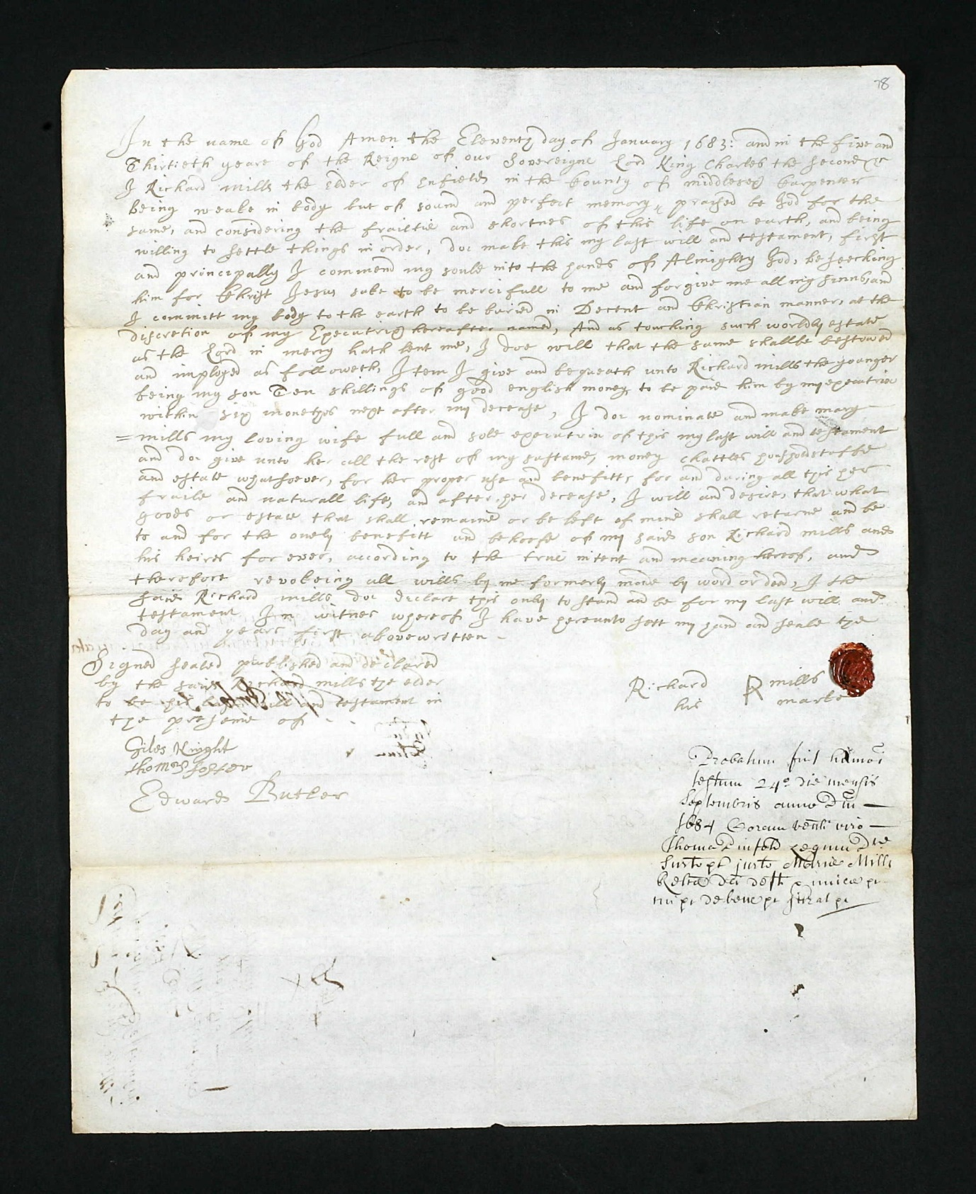

In the name of God amen the Eleventh day of January 1683: and in the five and Thirtieth yeare of the Reigne of our Sovereigne Lord King Charles the second &c I Richard MILLS the elder of Enfield in the County of Middlesex Carpender being weake in body but of sound and perfect memory, praised be God for the same, and considering the frailtie and shortnes of this life on earth, and being willing to settle things in order, doe make this my last will and testament, first and principally I commend my soule into the hands of Almighty God, beseeching him for Christ Jesus sake to be mercifull to me and forgive me all my sinns, and I committ my body to the earth to be buried in Decent and Christian manner, at the discretion of my Executrix hereafter named, And as touching such worldly estate as the Lord in mercy hath lent me, I doe will that the same shallbe bestowed and imployed as followeth,

Item I give and bequeath unto Richard MILLS the younger being my son Ten shillings of good english money, to be paid him by my executrix within six moneths next after my decase, I doe nominate and make Mary MILLS my loving wife full and sole executrix of this my last will and testament and doe give unto her all the rest of my sustance, money, chattles, housholdstuffe and estate whatsoever, for her proper use and benefitt, for and during all this her fraile and naturall life, and after her decease, I will and desire that what goods or estate that shall remaine or be left of mine shall returne and be to and for the onely benefitt and behoofe of my said son Richard MILLS and his heires for ever, according to the true intent and meaning hereof, and therefore revokeing all wills by me formerly made by word or deed, I the said Richard MILLS doe declare this only to stand and be for my last will and testament In witnes whereof I have hereunto sett my hand and seale the day and yeare first abovewritten.

Signed/sealed Richard R MILLS his marke

Signed Sealed published and declared
by the said Richard MILLS the elder
to be his last will and testament in
the presence of
Giles KNIGHT
Thomas FOSTER
Edward BUTLER [regular Will witness, possibly local Minister]

Probate 24 Sep 1684 at the court of Thomas PINFOLD Surrogate, granted to Mary MILLS, Executrix named in the Will, relict of the deceased, sworn.

Not much more can be told from the will of Richard other than he was still living in Enfield at the time of his death. He was, at that point, remarried to a woman named Mary, and either he made provision for his other children as his father had, or his only surviving child was Richard Mills the younger. Mary received the household items, which would go to Richard the younger after Mary’s death. Also, Richard Mills the younger was to receive ten shillings within six months of Richard the elder’s death. One other point is that Richard was baptized using only the surname Milles in Sherington, the only surname he used in Enfield. He likely lived in Newport Pagnell as a young man, but no evidence was found of him returning to live there as an adult.

Family of Richard Mills the elder in Enfield

1652-12-09 mar Richard Mills of Newport Pagnell & Elz Wite of Wellingborough, Northamptonshire in Tottenham
1653-03-10 bap Richard Mills son of Richard & Elizabeth
1655-09-10 bap John Mills son of Richard & Elizabeth
1657-08-10 bap [blank] the [blank] of Richard Mills, brn July 26 (may have been Elizabeth, named in her grandfather’s will)
1659-09-05 bap Stephan Mills son of Richard
1684-04-22 bur Richard Mills the elder

Family of Richard Mills the younger in Enfield

1677-08-06 mar Richard Mills & Elinor Terry Clerkenwell, Middlesex, England
1678-07-30 bap Mary Mills dau of Richard & Ellinor
1682-03-10 bap Richard son of Richard the younger
1683-09-24 bap Anne Mills dau of Richard the younger & Ellinor
1683-09-26 bur Ann Mills dau of Richard the younger
1686-06-05 bur John Mills son of Richard & Elenor
1687-04-24 bap Ann Mills dau of Rich. & Elenor
1687-05-01 bur Ann Mills dau of Richard & Ellen
1688-10-18 bap Ellinour Mills dau of Richard & Ellinour
1691-04-13 bap Thomas son of Richard & Elinear
1691-09-05 bur Thomas Mills (May be a different Thomas as no parents were named, however very few that year have parents named in the register and there’s quite a few each month)
1692-12-26 bap John Mills son of Richard & Eleanour
1693-06-18 bur John Mills (burials in this time rarely listed anyone as a child or by other terms)
1725-02-19 bur Eleanor Mills (poor woman)

NOTE: Only Mary, Richard, and Ellinor appear to have survived to adulthood, though Thomas may have if the 1691 burial is not his.

Possible great grandchildren of Richard Mills the elder in Enfield

1717-06-22 bur a child of Richard Mills
1719-03-08 bap Thomas son of Richard & Phebey Mills
1719-12-27 bur Thomas Mills (PR does not list any parents in this time-so this could be a different Thomas)
1721-03-26 bap Joseph son of Richard and [blank] Mills (in PR and account book)
1722-12-08 bur Joseph Mills (no bur entries had parents listed)

1724-04-26 bap Elizbeth dau of Richard & Elizabeth Mills
1725-03-07 bur Elizabeth Mills (bur entries had no parents listed)
1726-11-06 bap Richard son of Richard & Elizabeth
1727-08-23 bur Elizabeth Mills
1728-03-24 bur Richard Mills

The Enfield baptisms conclude the likely possibilities found for Richard’s descendants. Although it’s possible more descendants lived in Enfield and nearby parishes, the surname Mills is so common in London and we can’t be sure.

England, Buckinghamshire, Sherington, Bishop’s Transcripts for Sherrington, 1576-1839, children of Raphe Kendall als. Miles, 1613-1638, FHL microfilm 1,999,452 items 4-6; digitized images, Family Search (www.familysearch.org : accessed 13 April 2023).
“Woburn Settlers,” Great Migration Newsletter 15 (2006): 20-21; ; image copy, American Ancestors (www.americanancestors.org : accessed 9 May 2023), Francis Kendall 1640.
“Phillimore’s Middlesex Parish Registers, vol 9,” database with images, Find My Past (www.findmypast.co.uk: 17 Jul 2023), Richard Mills & Elizabeth Wite, image 40.
“London, England, Church of England, Baptisms, Marriages, and Burials, 1538-1812,” database with images, Ancestry (www.ancestry.com : accessed 6 July 2023), Richard Mills 1653.
“London, England, Church of England, Baptisms, Marriages, and Burials, 1538-1812,” database with images, Ancestry, John Mills, 1655.
“London, England, Church of England, Baptisms, Marriages, and Burials, 1538-1812,” database with images, Ancestry, Unk Mills, possibly Elizabeth, 1657. “Wills” database, Buckinghamshire Council Archives (https://shop.buckscc.gov.uk : accessed 25 April 2023), pdf of Rafe Kendall als. Miles, 1661.
“Wills” database, Buckinghamshire Council Archives (https://shop.buckscc.gov.uk : accessed 25 April 2023), pdf of Rafe Kendall als. Miles, 1661.
“London, England, Church of England, Baptisms, Marriages, and Burials, 1538-1812,” database with images, Ancestry, Stephan Mills, 1659.
England, Buckinghamshire, Newport Pagnell, Parish Register for Newport Pagnell, 1558-1718, bur. Raphe Kendall als. Miles, 1658/9, FHL microfilm 1042392, items 14-16; digitized images, Family Search (www.familysearch.org : accessed 13 April 2023).
“Wills” database, Buckinghamshire Council Archives, pdf of Rafe Kendall als. Miles, 1661.
“England & Wales, Prerogative Court of Canterbury Wills, 1384-1858,” database with images, Ancestry (www.ancestry.com: accessed 15 March 2023), John Kendall, 1666.
England, Buckinghamshire, Newport Pagnell, Parish Register for Newport Pagnell, 1558-1718, bur. John Ken[dall] 1666, FHL microfilm 1042392, items 14-16; digitized images, Family Search (www.familysearch.org : accessed 13 April 2023). Although the binding is too tight to see beyond John “Ken,” it is likely Richard’s brother as there are no other possible burial entries for him in Newport Pagnell before his will was probated.
“London Hearth Tax-City of London and Middlesex, 1666,” transcript only, British History Online (https://www.british-history.ac.uk/london-hearth-tax/london-mddx/1666/enfield : accessed 30 Jun 2023). Although six hearths was well above the average, Richard may have operated his business from his home, necessitating more hearths at the location.
The National Archives of the UK (TNA) Chancery ref. C 8/172/47 (1670), John Kendall als. Mills vs Richard Kendall als Mills, William Bristowe and Martha Kendall. The essence of this case is that John Jr, son of the John who died in 1666, felt he deserved more of the inheritance his father apparently left to him in his will.
“London, England, Church of England, Baptisms, Marriages, and Burials, 1538-1812,” database with images, Ancestry (www.ancestry.com : accessed 6 July 2023), John Mills bur, 1675.
London Metropolitan Archives, City of London, ACC/1751/009 (1677), Indenture of Lease for Richard Mills als. Kendall.
Robert Hovenden, Editor, “A True Register of the Christenings, Mariages, and Burrialls in the Parishe of St. James Clerkenwell, from the Year of Our Lord God 1551, Vol 3 Marriages 1551-1754,” The Publications of the Harleian Society, 1887 (London, England: The Harleian Society, 1887); digital images Family Search (www.familysearch.org : accessed 14 Jul 2023), 184.
England & Wales, Prerogative Court of Canterbury Wills, 1384-1858,” database with images, Ancestry (www.ancestry.com: accessed 15 March 2023), children of Richard & Eleanor Mills.
“London, England, Wills and Probate, 1507-1858,” database with images, Ancestry (www.ancestry.com : accessed 30 Jun 2023), Richard Mills, 1684.
England & Wales, Prerogative Court of Canterbury Wills, 1384-1858,” database with images, Ancestry (www.ancestry.com: accessed 15 March 2023), Richard Mills, 1684.
“London, England, Wills and Probate, 1507-1858,” database with images, Ancestry (www.ancestry.com : accessed 30 Jun 2023), Richard Mills, 1684.
“London, England, Church of England, Baptisms, Marriages, and Burials, 1538-1812,” database with images, Ancestry (www.ancestry.com : accessed 6 July 2023), baptisms and burials for children of Richard Mills in Enfield 1717-1722.
“London, England, Church of England, Baptisms, Marriages, and Burials, 1538-1812,” database with images, Ancestry (www.ancestry.com : accessed 6 July 2023), baptisms and burials for children of Richard Mills in Enfield 1724-1728.
“Wills” database, Buckinghamshire Council Archives (https://shop.buckscc.gov.uk : accessed 25 April 2023), pdf of Rafe Kendall als. Miles, 1661.
Newport Pagnell, Buckinghamshire, original deed of gift DB 1111/2, Ralph Kendall als Mills to John Kendall als Mills (1654); Aylesbury Buckinghamshire Record Office.
“Wills” database, Buckinghamshire Council Archives, pdf of Rafe Kendall als. Miles, 1661.
“London, England, Church of England, Baptisms, Marriages, and Burials, 1538-1812,” database with images, Ancestry (www.ancestry.com : accessed 6 July 2023), children of Richard Mills 1653-1659.
“London, England, Wills and Probate, 1507-1858,” database with images, Ancestry (www.ancestry.com : accessed 30 Jun 2023), Richard Mills, 1684.
“London, England, Church of England, Baptisms, Marriages, and Burials, 1538-1812,” database with images, Ancestry (www.ancestry.com : accessed 6 July 2023), possible family of Richard Mills 1652-1684.
“London, England, Church of England, Baptisms, Marriages, and Burials, 1538-1812,” database with images, Ancestry (www.ancestry.com : accessed 6 July 2023), family of Richard Mills 1677-1725.
“London, England, Church of England, Baptisms, Marriages, and Burials, 1538-1812,” database with images, Ancestry (www.ancestry.com : accessed 6 July 2023), Richard Mills family members 1717-1728.

